

ORBITA, TARRA, KAPRRI, TISSA
ORBITA e, TARRA e, KAPRRI e, TISSA e
OPERATING AND MAINTENANCE INSTRUCTION
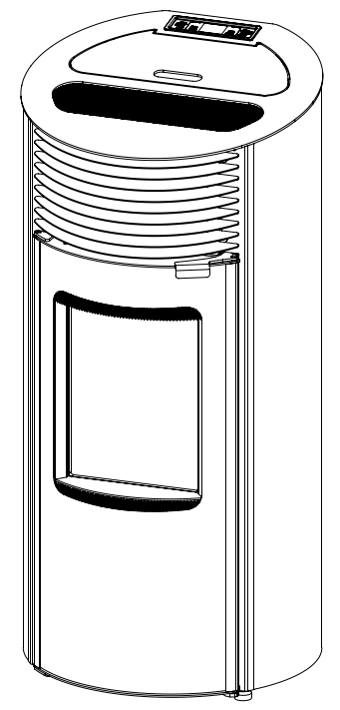 | 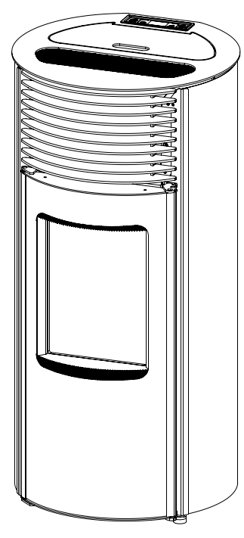
ORBITA, ORBITA e | TARRA, TARRA e
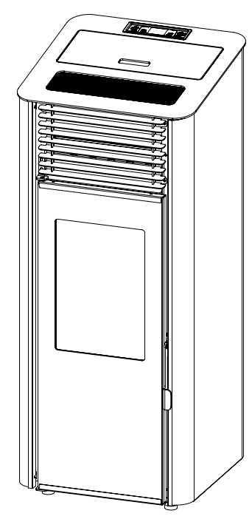 | 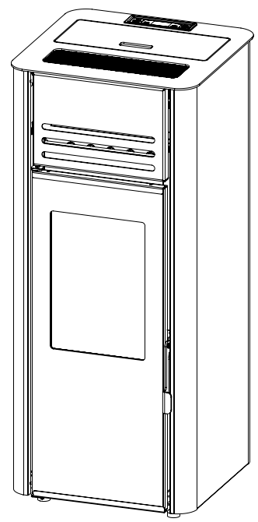
KAPRRI, KAPRRI e | TISSA, TISSA e


EN 14785:2006 V1/04.20

CONTENT

1. ABOUT PELLET 3
1.1 QUALITY OF PELLET 3
2. REMARKS BEFORE OPERATING THE STOVE 4
3.1 1 STOVE DIMENSION: 7
6. DISPLAY AND A REMOTE CONTROL 13
Table 2. Symbols on the display 14
6.2. Remote control 14
7.1. Turning ON and turning OFF the stove 16
7.2. Temperature and mode settings 19
8. SETTINGS – USERS MENU 20
8.1. MENU 01 – Setting clock 22
Press Key 6 to make step back if needed. To exit clock setting, press Key 4. twice. 22
8.2. MENU 01 – Setting clock 23
8.2.1. MENI 02-01 Turn on the timer 23
8.2.2. MENU 02-02 Daily program 25
8.3.3. MENU 02-03 Weekly program 27
8.2.4. MENU 02-04 Program Week-end 29
8.3. MENU 03 – Language selection 31
8.4. MENI 04 - MENU 04 - Set STAND-BY mode 31
8.5. MENU 05 – Set sound-alert 32
8.6. MENU 06 – Initial loading 33
8.8. Technical calibration 35
9. ALARMS 35
10. CLEANING AND MAINTENANCE 39

1. ABOUT PELLET

Pellet is an energy fuel with high energy efficiency, which is produced in special technological process of milling, drying and pressing of various materials of biological origin. As raw materials for its production can be used wood from forestry waste, firewood, sawdust and other wood waste (Wood pellets); the straw of wheat and soybeans, corn and sunflower husks (agro pellets).
Nowadays, when the accent has been put on environmental protection and sustainable development, fuels produced from biomass are increasingly gaining in importance.
Using pellets as a fuel material has multiple advantages either for the environment or, at the first place, for a customer itself:

- Using one ton of pellets, for the same heating quantity, replace 500 liters of heating oil, or 450 kg of propane-butane, or 600 cubic meters of natural gas, or 4800 kilowatt-hours of electricity;
- It significantly reduces emission of harmful gases, such as: carbon dioxide, sulfur dioxide and mercury, and the burning leaves only 0.5 - 1% of ash;
- Wood pellet is made of 100% natural materials and contains no added binders, chemicals or additives;
- Compared with other fuels or using electricity, the use of pellets is much more cost-effective
- Pellet takes up far less space than coal and firewood.

1.1 QUALITY OF PELLET

The quality of pellets is of great importance for the stove.
If the pellet is substandard and inadequate in size, it can bring to a poor performance of the stove.
Here are some advices on how to choose and store pellets:

- Diameter of the pellets should be 6 mm and length about 30 mm;
- Use only wood pellets;
- Pellet should be cylindrical;
- Good quality pellet should quickly sink when thrown into a glass of water;
- Pellet is not adequate when in a bag of pellets you find a lot of dust or friable;
- Pack of pellets should be hermetically sealed, because pellets absorbed humidity;
-humidity must be less than 10%;
- Pellets are supposed to be stored in dry, well ventilated room, out of the reach of flammable elements or devices which during operation create a high temperature.

2. REMARKS BEFORE OPERATING THE STOVE

Always follow the references given in this chapter. The manufacturer doesn’t take a responsibility for consequences in opposite cases. Not respecting the instructions of use and maintenance, cause loss of your right to an warranty.

- Before operating the stove, please read this manual;
Before initial start of the stove, pellet storage and feeder (pellet transporter), are empty. Read chapter „8.6. MENU 06 – Initial loading on page 33 .
- During initial start, combustion products of the protective coating and the evaporation of paint from the installed parts may occur. In this case, it is imperative to ventilate the room until products and odors are eliminated.
- Stove is used exclusively for heating;
- Keep the stove away from flammable materials;
- Keep the stove in dry places;
- Keep the children or pets away from the stove, because some parts emits high temperatures and they can cause burns;
- Do not touch the parts that emit a high temperature, such as smoke drain, glass, fire door, lateral sides;
- Ash from ashtray should be cleaned only after it get cold.
- Use wood pellet only
- Stove should be cleaned only when it is cold (stove is completely cooled after 30 minutes after turning off the stove);
- Stove should be cleaned only when it is disconnected from the power source on the main switch (Chapter: basic parts of the stove);
- In the room where stove is placed, it is necessary to ensure a permanent supply of fresh air;
- Stove must be installed in accordance with these manual (Section: stove installation).
- Do not open the doors while stove is operational.
- If the pellet gets stuck in the pellet transporter (feeder), turn off the stove and unplug it at the main switch. Clean the stuck pellet. Then start the stove again.
- DO NOT PUT YOUR HAND IN PELLET STORAGE WHILE STOVE IS OPERATIONAL!

Stove and its packaging are made of materials that can be recycled.
Stove, which is not in use any more, should be put away in an adequate place or you should call the service for waste disposal. You should act according to regulations in force in the country where the stove is placed.
Dispose of the packaging in which the stove was packed in the designated place or call a waste disposal service.
For any defect you need to call a qualified technician. All defects must be removed by an authorized service technician. In case that an unauthorized person repairs the stove,
You will automatically lose rights to a warranty and any further repairs by an authorized service will be charged.

NOTE:
Each stove before packing requires the operation and safety control.
Therefore, it’s possible to find some burning remains in the firebox. It is also possible to find a small amount of pellets in the hoper.

During the first firing, some paint burning can occur.
Therefore, it’s recommended to ventilate the room well during and after first burning.
3. TECHNICAL CHARACTERISTICS

Technical characteristics are presented in table below:
Heat output / Power | kW | 6 kW | 8 kW
Dimension (W x L x H) Orbita / Orbita e | mm | 529 x 509 x 1130
Dimension (W x L x H) Tarra / Tarra e | mm | 533 x 508 x 1099
Dimension (W x L x H) Kaprri / Kaprri e | mm | 472 x 444 x 1131
Dimension (W x L x H) Tissa / Tissa e | mm | 459 x 443 x 1094
Nett weight Orbita / Orbita e | Kg | 103,5 / 96
Nett weight Tarra / Tarra e | Kg | 98,5 / 95,5
Nett weight Kaprri / Kaprri e | Kg | 104,5 / 97
Nett weight Tissa / Tissa e | Kg | 98 / 95
Fuel – wood pellet (dimensions) |  | Ø6 mm L=30mm
Fume exhaust | mm | Ø80
Draft | Pa | 12±2
Pellet storage capacity | Kg | 19
Voltage | V | 230 ± 15%
Frequency | Hz | 50
Electrical power during the operation | W | 55 – 160 *
Electrical power during the initialization | W | 400 – 450 **
Energy efficiency at nominal power | % | 91,3 | 91,3
Energy efficiency at minimal power | % | 92 | 92
Nominal power | kW | 6,0 | 8,0
Minimal power | kW | 2,8 | 2,8
Fuel consumption-nominal | Kg | 1.4 | 1,83
Fuel consumption-minimal | Kg | 0,63
CO (at 13% O₂) | mg/Nm³ | 106 | 105
CO (at 13% O2) at min.power | mg/Nm³ | 107 | 107
Dust | mg/Nm³ | 13 | 15
NOx | mg/Nm³ | 111 | 95
OGC | mg/m³ | 6 | 20
Flue gas temperature at nominal power | ºC | 116 | 127
Operating temperature | ºC | 5 – 60
Storage temperature | ºC | -10 – 60
Max. relat. humidity (without condensation) | % | 95

* depending of which fan is on, as well as the motor reducer

** Lighter and emissions fan is on (400W), while motor reducer is occasionally getting on.

3.1 1 STOVE DIMENSION:
Images 1a - 1d, are presenting stoves dimensions.

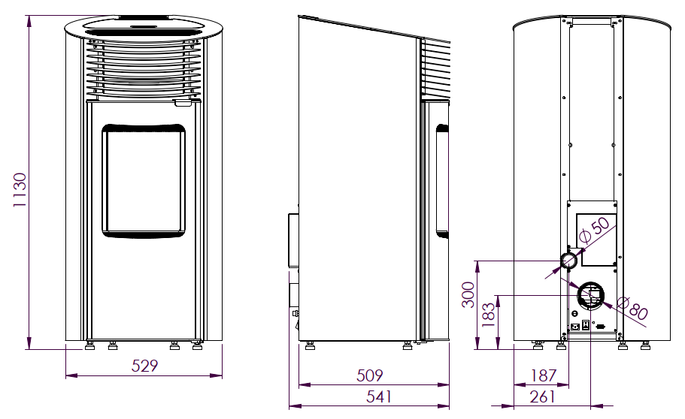
ORBITA, ORBITA e Image 1a.
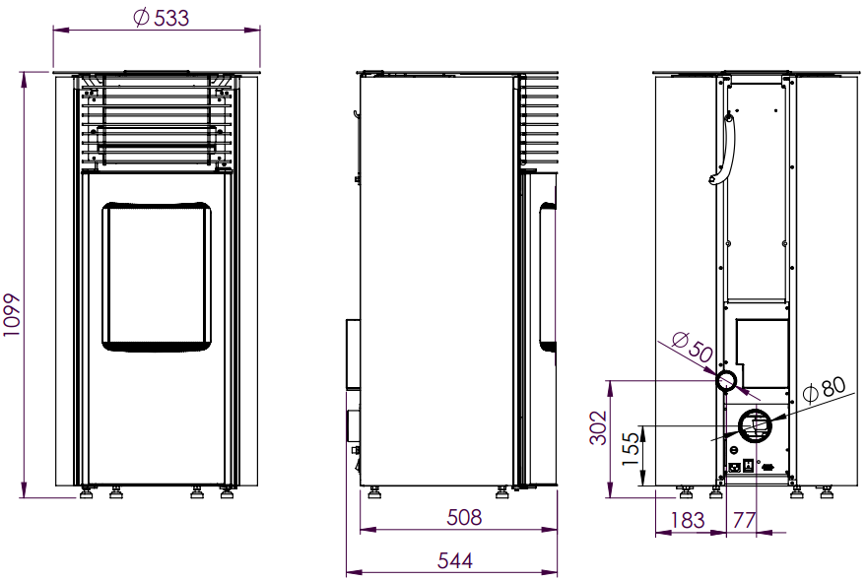

TARRA, TARRA e Image 1b.

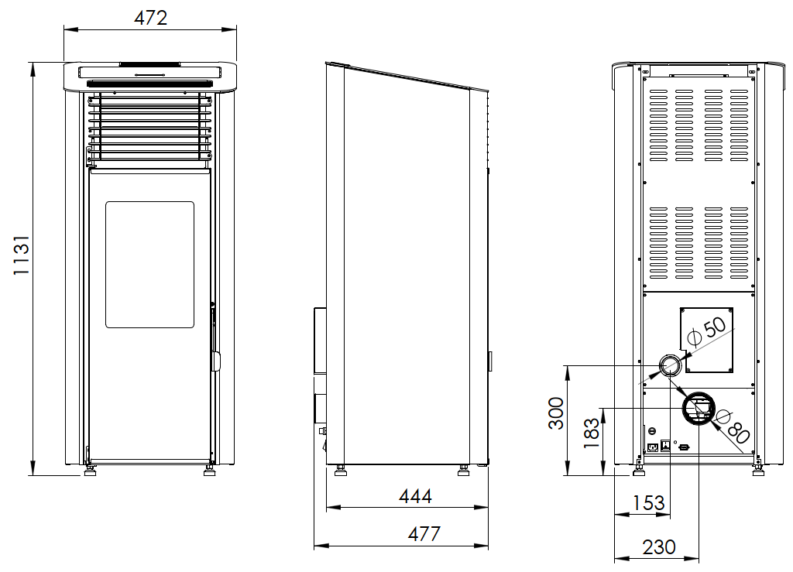
KAPRRI, KAPRRI e Image 1c.
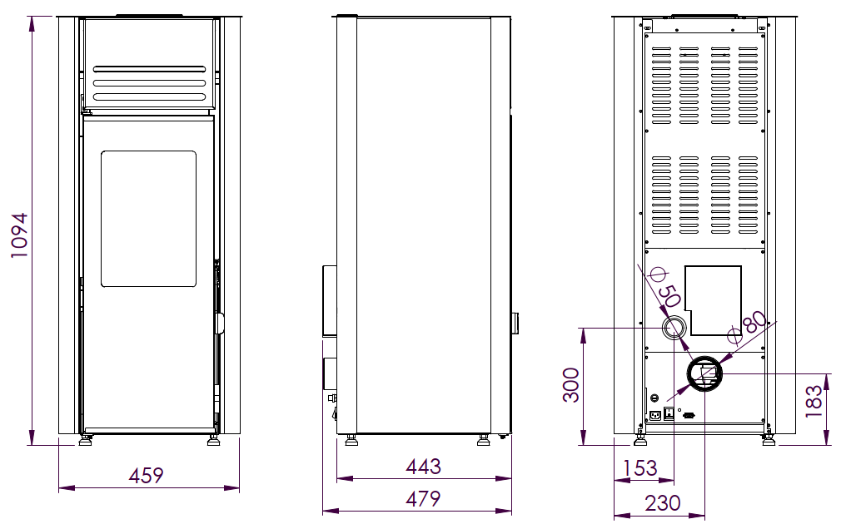
TISSA, TISSA e Image 1d.
4. BASIC FEATURES OF THE STOVE

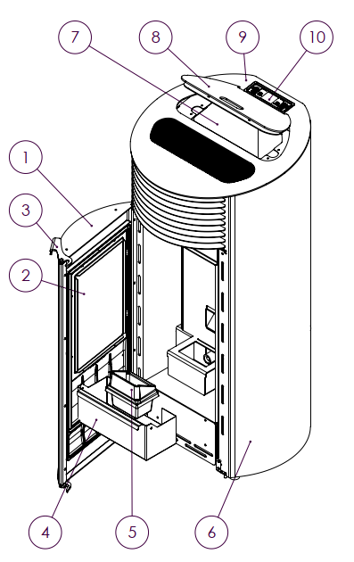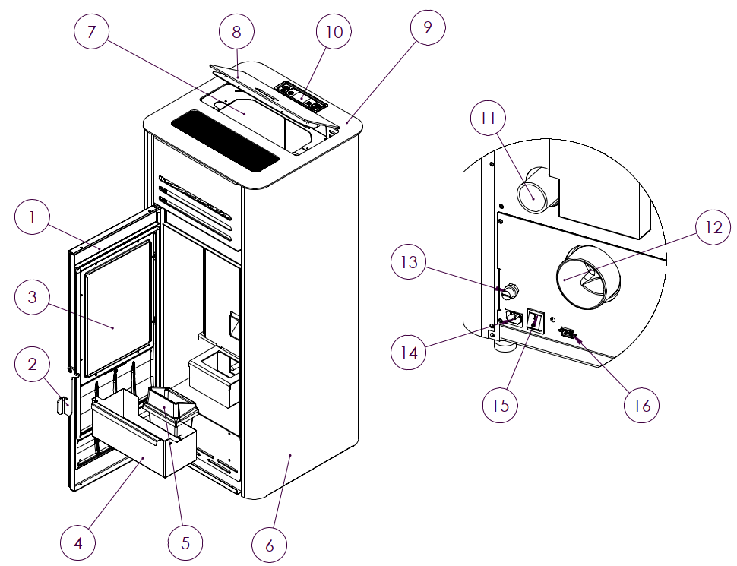

ORBITA TISSA
Image 2.

Image 2a presenting basic features and basic parts of ORBITA and TISSA.

1. Firebox doors | 9. Top plate
2. Door glass | 10. Display with commands
3. Door handle * | 11. Primary air
4. Ashtray | 12. Fume exhaust
5. Burning pot | 13. Safety thermostat
6. Lateral panel | 14. Socket
7. Pellet storage | 15. Main switch
8. Storage cover | 16. Communication port (RS232)
* Door handle ,in case of TARRA stove is separate part and it should be kept in the hook on the rear side of the stove. Check chapter 10. Cleaning and meintenance

Note: Real appearance of stove my look differently than drawing in Manual.
5. INSTALATION OF THE STOVE
With a stove you will get the user’s manual, remote control and power cable.  These accessories, included with the stove are presented on an Image 3. | 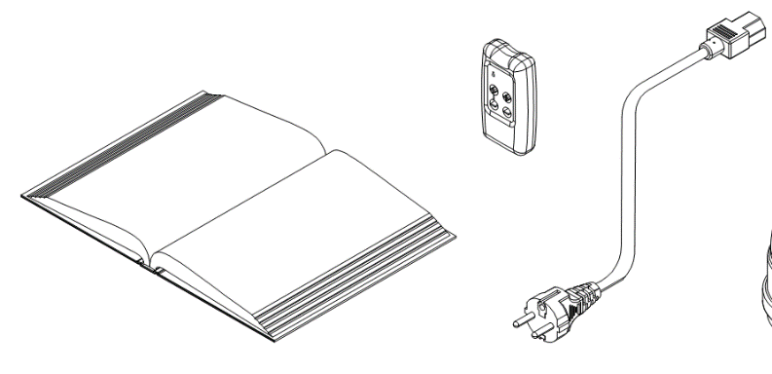  Image 3

Before you start installation of the stove, you must read carefully instructions for use and maintenance get to know well a regional regulations and legislation, in order to apply them. You must provide enough air in the room where the stove is placed in order to provide an optimal combustion.
Stove should be placed close to chimney and close to electric energy supply.

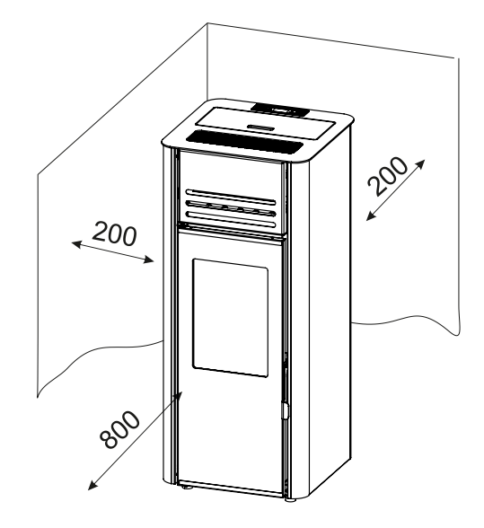  Image 4. | Distance from flammable material or unprotected wall is presented in Image 4.  Stove should be set 300 mm away from the obstacle on its sides, 300 mm from the back side, while the front side should be at least 800mm away from obstacles. Do not place any objects on the stove, because they could be damaged by a high temperatures that the stove emits. Sheet metal or a thicker glass of, minimal dimensions 700 x 800 mm could be used as floor protection below the stove in a way that the front part is longer than the stove itself.
The stove stands on adjustable feet which must be set so that the stove is stable.
Feet are being adjusted by simple unscrewing or twisting.
It is necessary to provide sufficient air supplies to the chimney so the stove could function smoothly. The easiest way to check whether the chimney is operating well is to get close to a smoke drain with a lighter or a candle flame. If the flame is vertical as it was before, away from the chimney, then you should check whether the chimney needs to be cleaned, or is there some other problem in between. If the flame sways toward the mouth of the chimney, there is quite sufficient air flow. All irregularities in the functioning of the chimney must be removed before initializing the stove.
When connecting the stove with smoke drain and flue tubes, check carefully if all connections are well sealed, so that gases do not to enter the room where the stove is located.
Flue pipe must not be too drawn into the chimney.

There is a power cord included with stove. Connected the stove to the power source voltage of 230V and 50Hz. Stove must be connected only to the required socket. Image 5 shows how the stove is connected to a power source. Before plugging in the cable, check if the main switch is set to the position 0.Note that the power cord is not damaged. Cable must be disconnected from the heat source. First, turn the cable into the stove to the required space and then into a power socket.
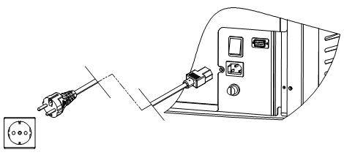
Image 5. Connecting the stove to power source

FUME PIPES AND MAXIMAL LENGHT
In order to provide full hermetic connection of tubes, silicon sealed tubes must be used. Connection of exhaust fan with exhaust pipes made in diameter of Ø80 mm . All sections of fume pipes should be able to be dismantled for periodical cleaning.
It is not allowed to use flexible tubes for fume exhaust system.
Tee – fume pipe is obligatory and it must be used because of regular cleaning, seasonal maintenance and removing of soot.
Horizontal distance between stove and chimneys wall connector should not be bigger than 1m. It is maximal allowed length for connecting with chimney. Exhaust fume pipes should be used with maximum 3 pcs of 45- 90° elbows. Vertical exhaust should not be higher than 2m before connection with wall connector.
Exhaust diameter is Ø80 mm.
Wind and rain protector on the top of the chimney is obligatory according to standards.

CONNECTING TO EXTERNAL AIR INLET

External air inlet connector in diameter of Ø50 mm is positioned on the rear side of the stove.
If use of external air inlet is not possible, it is absolutely obligatory to provide fresh air in the room where stove is situated.
USE OF EXTERNAL CHIMNEY
External chimney is possible to use only id following conditions are fulfilled:

- Only double walled tubes with insulation are allowed for use.
- Inspection and cleaning doors must be provided on the bottom of the external chimney.
- Condensation pot must be mounted on the bottom of the chimney
- Top cover must be used as protection from wind, rain and snow.

NEVER USE ONLY HORISONTAL EXHAUST WITHOUT WIND PROTECTION!

PRODUCER IS NOT REPSONSIBLE FOR MALFUNCTIONS CAUSED IF ABOVE MENTIONED CONDITIENS ARE NOT RESPECTED!

Images 6a and 6b. are presenting correct connection of the stove and external chimney.
6a present direct connection. 6b presents connection with indoor pipes included. Both cases request use of T and condensation pot. Periodical cleaning of T and condensation pot is obligatory and it depends on use and quality of pellet. External chimney must be insulated and double walled.
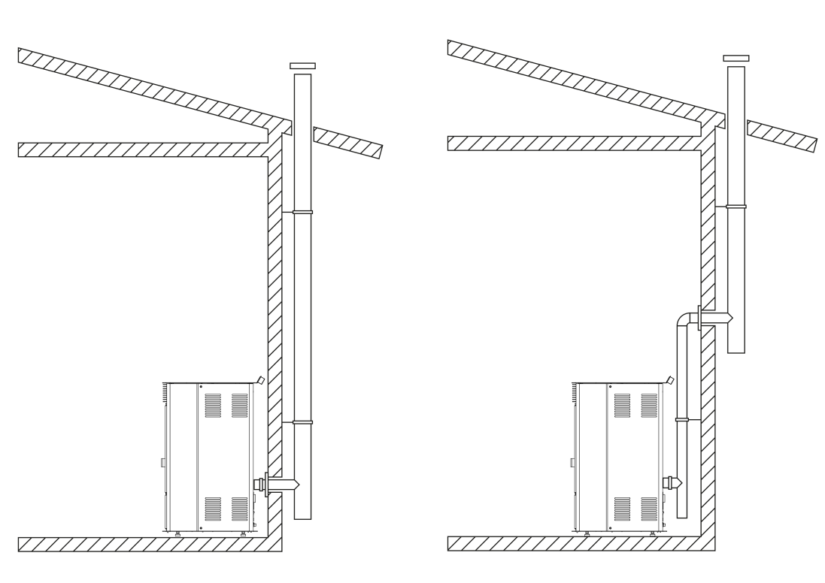
Image 6a. Image 6b.

6. DISPLAY AND A REMOTE CONTROL

There is 6 keys on display 6 keys which are being used for managing different functions of the stove. In the middle, there is a screen which shows basic information related stove operation. Image 7. presents a display appearance and content.
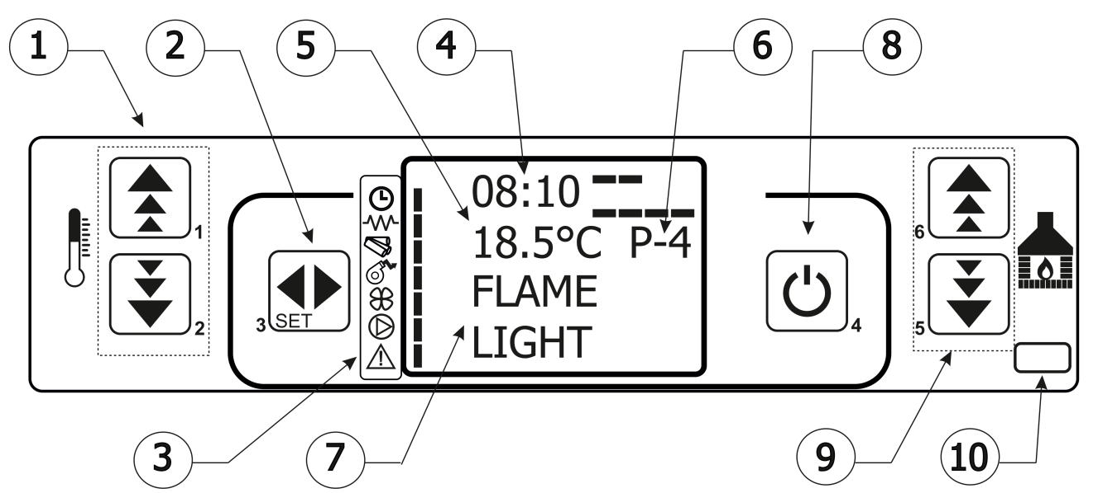
Image 7. Display appearance and content

1. Temperature setting keys
2. Main menu entering keys
3. Indicators of the stove parts
4. Clock
5. Room temperature display
6. Modes of operation
7. Current status information
8. On/Off switch, exit key
9. Mode setting keys (increase/decrease power)
10. Sensor of remote control

6.1. Symbols of the stove electric components (devices)

Next to each symbol, there is an indicator light showing which of the components is currently on. Auger indicator will be periodically turned on and off depending on whether the engine for the insertion of pellets is on or off.
Description of symbols is presented in Table 2.

 | Timer indicator (turning the on and off according to a selected program)
 | Heater indicator for burning the pellet
 | Auger
 | Exhaust fan indicator
 | Room fan indicator
 | Water pump indicator  (optional and related only to a stoves for central heating)
 | Alarm indicator

Table 2. Symbols on the display

6.2. Remote control

With a remote control, a battery will be delivered. In order to use the remote control, you need do buy a battery of 12V, P23GA type. Image 8. represents a remote control .
Basic commands on remote control :  - Key 1 – Increasing of room temperature  - Key 2 – Decreasing of room temperature  - Key 3 – Turning ON/OFF  - Key 4 – Entering MENU  - Key 5 – Increasing power (Mode)  - Key 6 – Decreasing power (Mode) | 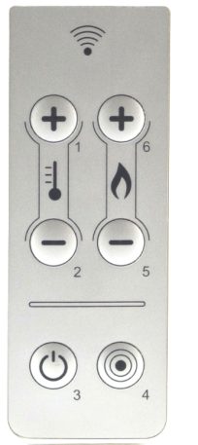
Image 8. Remote control
Stove is turned on or off by pressing Keys 1 and 6 in the same time. Use Keys 1 and 2 to set room temperature. Use Keys 5 and 6 to change power (Mode). It is described in Chapter “USING THE STOVE”.

Table below is presenting detailed commands which can be executed by pressing 1-6.

Key | Description |  | Mode |  | Action
1 | Increase  temperature | Programming |  | Adjust/increase the value in the selected menu
1 | Increase  temperature | ON / OFF |  | Increase the temperature value of the room thermostat
2 | Decrease  temperature | Programming |  | Tuning / decreasing value in selected menu
2 | Decrease  temperature | ON / OFF |  | Decrease the temperature value of the room thermostat
3 | Menu | - |  | Accesses the menu
3 | Menu | Menu |  | Accesses the submenu level
3 | Menu | Programming |  | Sets the value and moves to the next menu
4 | ON / OFF Unlock | ON |  | Hold for 2 seconds to switch the stove on when in off mode, or off when in on mode
4 | ON / OFF Unlock | Lock |  | Unlocks the stove and puts it into off mode
4 | ON / OFF Unlock | Menu / Programming |  | Brings you to the next menu level, any adjustments made will be saved
5 | Increase  power | ON / OFF |  | Adjust the power produced by the stove
5 | Increase  power | Menu |  | Takes you to the next menu level
5 | Increase  power | Programing |  | Takes you to the next submenu, any adjustments made will be saved
6 | Decrease power | ON / OFF |  | Adjust the speed of the exchanger
6 | Decrease power | Menu |  | Takes you back to the previous menu level
6 | Decrease power | Programming |  | Takes you to the previous submenu, any adjustments made will be saved

7. USING THE STOVE

Follow this Manual always, so that the stove remains in good condition as long as possible and to avoid unnecessary costs. Before initializing the stove, check to see if the stove is well connected to the power source and the chimney.

7.1. Turning ON and turning OFF the stove

Note: During first igniting, pellet storage and feeder (pellet tranporter) are empty.

Read chapter "8.6 MENU M6 – INITIAL LOADING" on page 33, before starting
the stove.

To turn on the stove, change the main switch from position 0 to position 1.
Screen shows: clock, room temperature, operating regime (Power from P1 to P5) and OFF (stove is turned off), as on Image 9.
The stove is being turned on and off by pressing the key 4. For minimum 4 seconds until screen show START. (Image 10).

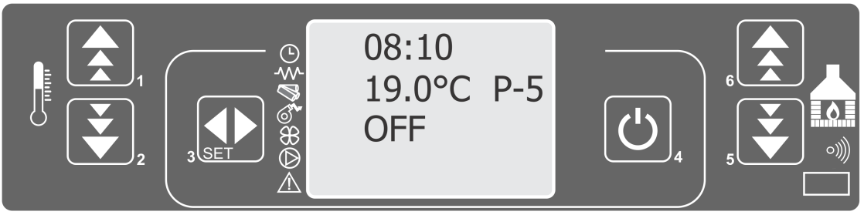
Image 9.

During start , indicators which presents stove components will light on. Exhaust fan will be on as long stove is operational and for some time after stove is turned off (for safety cooling reasons).

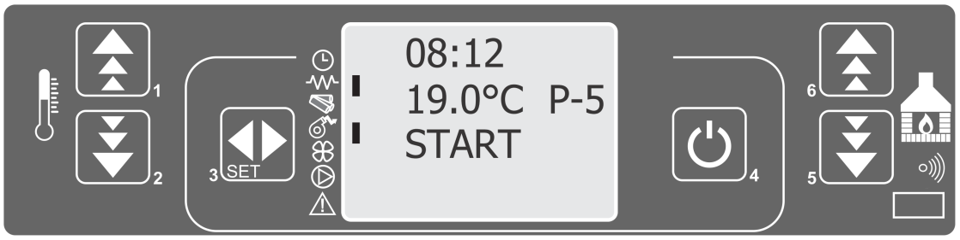
Image 10.

Message which will appear is PREHEATING WAIT (Image 11), which marks that igniter has started to heat the pellet. Screen will show indicator of igniter and exhaust fan.

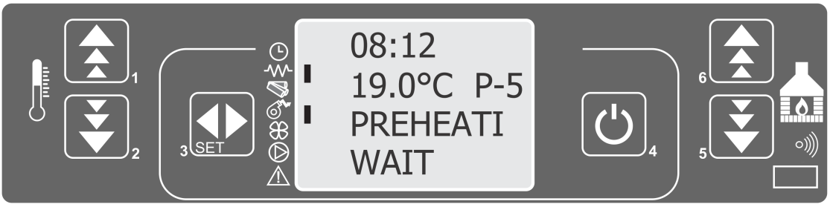
Image 11.

Stove will automatically insert the quantity of pellet which is needed for kindling and screen will show PELLET LOAD (Image 12). Auger indicator will light on only in moment when auger is active.

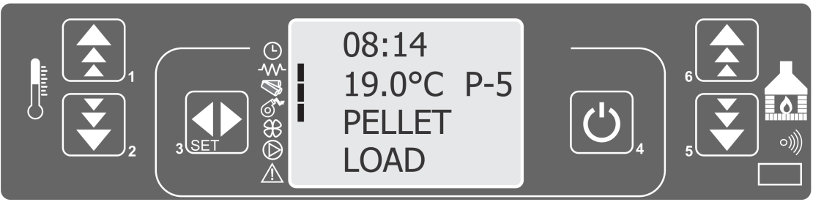
Image 12.

Screen will show text LOAD PELLET and FLAME WAIT alternately (Image 13), till temperature of exhaust gasses get over 40ºC which is a signal to control unit that stove could start to work maximal period of time to reach 40ºC is 25 minutes.

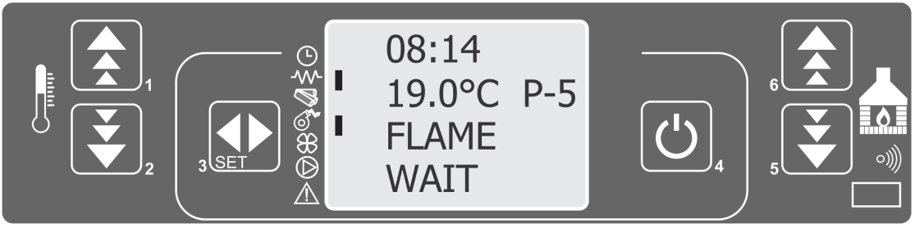
Image 13.
After temperature of exhaust gasses is (40ºC), temperature probe detects temperature increase in turbine of exhaust gases.. Screen will show FIRE PRESENT (Image 14), which means that stove has detected flame and that it will enter operating mode in 3 minutes.
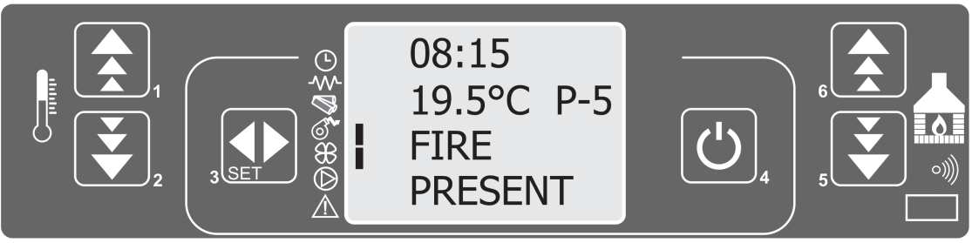
Image 14.
After the flame is formed in the burning pot, stove is turning igniter off. When temperature reach value which is determined by technical parameters, convection fan is starting on.
OPERATING MODE

After period which is determined by technical parameters, stove is entering operating mode Operating mode is presented with text WORK (Image 15).
Indicators visible next to screen are:
- Fan of exhaust gases,
- Convection fan,
- Auger (periodically).

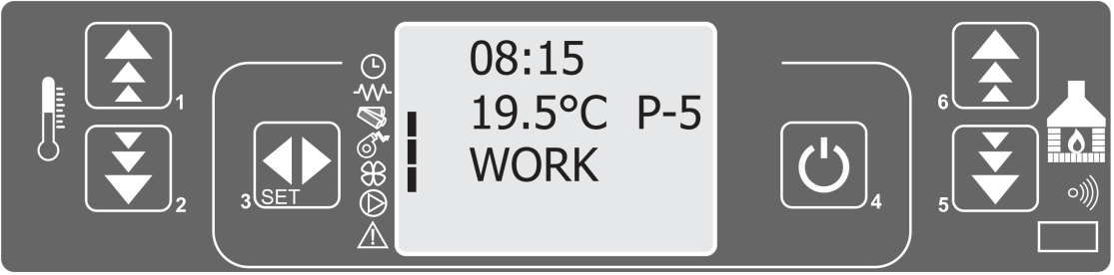
Image 15

Periodically, stove is cleaning the burning pot, which is presented with text BURN POT CLEANING (Image 16). Cleaning of burning pot is done according determined program which increase speed of exhaust fan decrease auger intervals so pot „gets clean“ of unburned pellet after certain period of time and only embers needed for new pellet remain in pot. The time period between two cleanings and the duration of cleaning varies depending on the stove model.
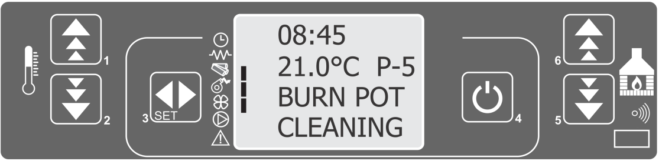
Image 16.

TURNING OFF THE STOVE
When shutting down the stove, you need to press key 4 and keep it that way for a while, until screen shows CLEANING FINAL. Stove will blow warm air in the room until the fire chamber get cooled to a temperature of 75 º C. After certain period, screen will display text OFF, which means that the stove is turned off.
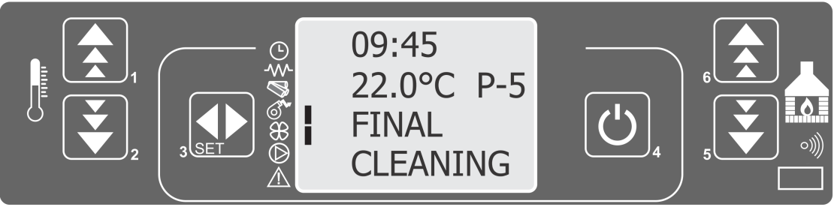
Image 17.

7.2. Temperature and mode settings

Temperature setting is done by pressing keys 1 or 2.
Stove will be heated to a certain temperature and then maintain the same one. Command is done by pressing the key 1 or 2 briefly. After that, push the same Keys to set the temperature up or down.
This action will be followed with a text SET ROOM TEMP (Image 18.). Temperature can be changed in the interval from 7 to 40 º C.

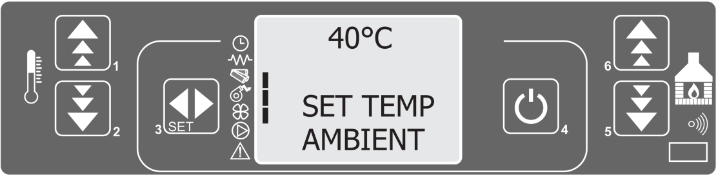
Image 18.

Mode setting is done by pressing the key 5 or 6. Modes can be changed from P1 to P5. Modes can be Changed by keys 5 and 6, which will be followed by the message SET POWER (Image 19). In higher mode, set temperature will be achieved faster, after which stove will switch to WORK MODULAT. It means that stove has reached the selected temperature that will be maintained with a lower regime.
(Mode « Modulation» is actually P1 – regime with lowest power).
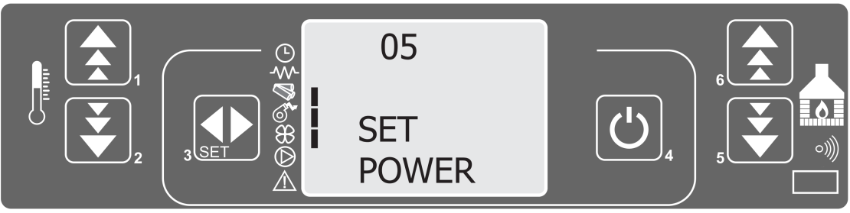
Image 19.

8. SETTINGS – USERS MENU

To access Menu, press Key 3. Menu is formed in several levels and sub levels. The following table briefly describes the menu structure, specifically the settings available to the user.
Level 1 | Level 2 | Level 3 | Value
01 – Set clock
 | 01 - day |  | day of week
 | 02 - hours |  | Hour
 | 03 - minutes |  | Minutes
 | 04 - day |  | Day of the month
 | 05 - month |  | Months
 | 06 - year |  | Year
02 – Set chrono
 | 01 – enable timer
 |  | 01 – enable timer | On/off
 | 02 - day program
 |  | 01 - daily timer | on/off
 |  | 02 - start day 1 | Time
 |  | 03 - stop day 1 | Time
 |  | 04 - start day 2 | Time
 |  | 05 - stop day 2 | time
 | 03 - week program
 |  | 01 - weekly time | on/off
 |  | 02 - start prog 1 | Time
 |  | 03 - stop prog 1 | Time
 |  | 04 - monday prog 1 | on/off
 |  | 05 - tuesday prog 1 | on/off
 |  | 06 - wednesday prog | on/off
 |  | 07 - thursday prog 1 | on/off
 |  | 08 - friday prog 1 | on/off
 |  | 09 - saturday prog 1 | on/off
 |  | 10 - sunday prog 1 | on/off
 |  | 11 - start prog 2 | Time
 |  | 12 - stop prog 2 | Time
 |  | 13 - monday prog 2 | on/off
 |  | 14 - tuesday prog 2 | on/off
 |  | 15 - wednesday prog 2 | on/off
 |  | 16 - thursday pog 2 | on/off
 |  | 17 - friday prog 2 | on/off
 |  | 18 - saturday prog 2 | on/off
 |  | 19 - sunday prog 2 | Time
 |  | 20 - start prog 3 | Time
 |  | 21 - stop prog 3 | on/off
 |  | 22 - monday prog 3 | on/off
 |  | 23 - tuesday prog 3 | on/off
 |  | 24 - wednesday prog 3 | on/off
 |  | 25 - thursday pog 3 | on/off
 |  | 26 - friday prog 3 | on/off
 |  | 27 - saturday prog 3 | on/off
 |  | 28 - sunday prog 3 | on/off
 |  | 29 - start prog 4 | Time
 |  | 30 - stop prog 4 | Time
 |  | 31 - monday prog 4 | on/off
 |  | 32 - tuesday prog 4 | on/off
 |  | 33 - wednesday prog 4 | on/off
 |  | 34 - thursday pog 4 | on/off
 |  | 35 - friday prog 4 | on/off
 |  | 36 - saturday prog 4 | on/off
 |  | 37 - sunday prog 4 | on/off
 | 04 - weekend program
 |  | 01 - week-end timer
 |  | 02 - start 1
 |  | 03 - stop 1
 |  | 04 - start 2
 |  | 05 - stop 2
03 – Select language
 | 01 - English |  | Set
 | 02 - Italian |  | Set
 | 03 - Holandese |  | Set
 | 04 - Espanol |  | Set
 | 05 - Francais |  | Set
 | 06 - Deutch |  | Set
04- Stand-by mode |  |  | on/off
05 – Buzzer mode |  |  | on/off
06 – Initial loading |  |  | Set
07 – Stove state |  |  | -
08 – Technical setting |  |  | Password protected

8.1. MENU 01 – Setting clock

The pellet stove has the ability to turn on and off during the day which is regulated by programs. To program the stove, you must first set the clock and date on the display of the control unit. To do this, you need to access the time and date setting menu.
Setting the clock is as follows:
Press Key 3 (set), after which menu 01 SET CLOCK (Image 20) will be displayed.
Then, press Key 3 (set) again to enter the clock setting menu.
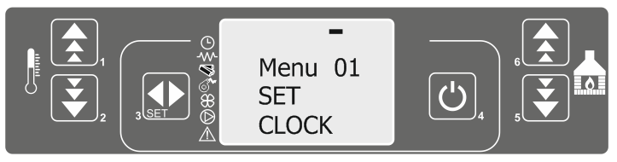
Image 20.

The text MENU 01 will appear on the screen and the day currently set will be displayed below it. The settings indicator light will start flashing. Pressing Key 1 and 2 changes the days as follows:
MONDAY
TUESDAY
WEDNESDAY
THURSDAY
FRIDAY
SATURDAY
SUNDAY -
Pressing Key 5 changes the following settings: day of the week: setting the hour, minutes, days, month and year.
Keys 1 and 2 adjust the parameters.
The screenshots are given in the following pictures:
Podešavanje sata | Podešavanje minuta | Podešavanje dana u mesecu | Podešavanje meseca | Podešavanje godine
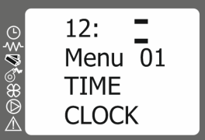 | 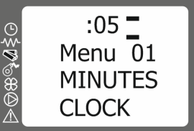 | 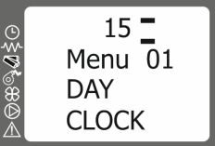 | 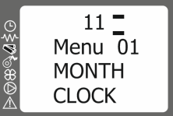 | 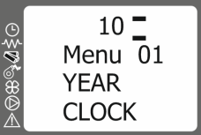

Press Key 6 to make step back if needed. To exit clock setting, press Key 4. twice.

8.2. MENU 01 – Setting clock

There are three types of timer settings:
- Daily - allows the oven to switch on and off twice a day
- Weekly - allows the furnace to be programmed so that it can be switched on and off 4 times a day for seven days a week
- Weekend - allows the stove to be turned on and off twice during the Saturday and Sunday.

8.2.1. MENI 02-01 Turn on the timer

The timer is switched on in the same way regardless of which type of setting is activated (daily, weekly or weekend program). The timer is switched on as follows:
Press key 3 (set), after which the screen will display the text menu 01 SET CLOCK. Then press the 5 key twice which is followed by the text menu 02 SET CHRONO (Image 21).

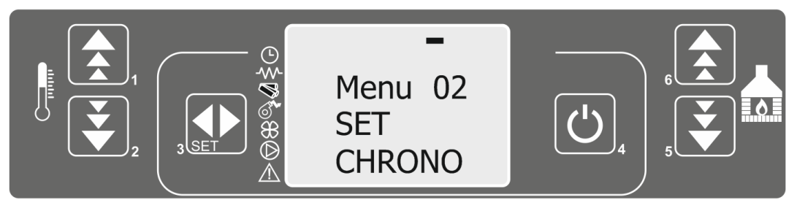
Image 21.

By pressing 3 (set) key , you enter the timer setting menu and therefore enter the timer menu activation. Text is displayed on the screen M-2-1 ENABLE CHRONO.
Then press key 3 (set) once more and it will display text OFF M-2-1-01 ENABLE CHRONO which means that the timer is off and the setting indicator flashes. Pressing 1 or 2 switches from off to on and the timer switches on (Image 22 and Image 23).

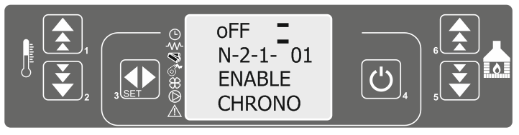
Image 22.

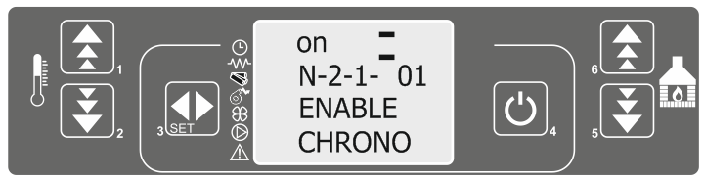
Image 23.

After the timer is switched on, the screen will turn on illuminating indicators that indicate which type of programming is activated (daily, weekly, weekend) as well as an indicator next to the clock symbol indicating that the timer is on. The screen layout and indicator labels are shown in the following Image.

1 - daily programming indicator | 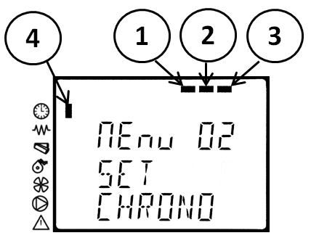
2 - weekly programming indicator
3 - weekend programming indicator
4 - timer indicator

To exit settings, press Key 4. twice.

8.2.2. MENU 02-02 Daily program

NOTE: During programming, the start-up and shut-down times of the stove must not overlap. At least 30 minutes must elapse between switching off and on!
During daily programming, it is possible to set two starts and two shutdowns of the stove.
Press key 3 (set), after which the screen will display the text menu 01 SET CLOCK. Press Key 5 twice, after which the screen will display the text menu 02 SET CHRONO. By pressing the key 3 Key (set,) enter the timer setting menu. The screen will display text ENABLE CHRONO. Press Key 5 again and the screen will display the text M-2-2 PROGRAM DAY (Image 24).

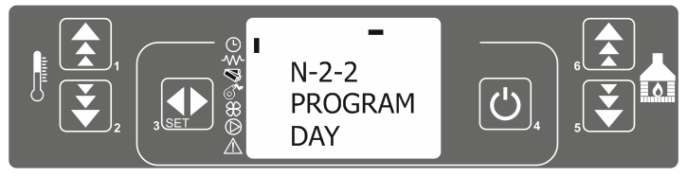
Image 24.

Press key 3 (set) again, and the screen will display text off m-2-2-01 CHRONO DAY. Use keys 1 and 2 to activate the day timer on (Image 25).
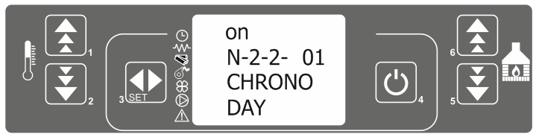
Image 25.

Use keys 5 and 6 to scroll through the menu, keys 1 and 2 to change parameters. The menu layouts are shown in the following table.
The times can be set at 10 minute intervals.

MENU | Setting options | Screen appereance
M-2-2-01 CHRONO DAY | off/on | 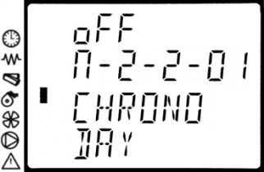
M-2-2-02 START 1 DAY | off/00:00-23:50 | 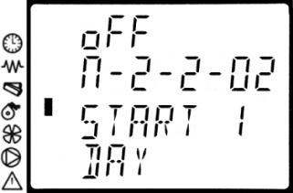
M-2-2-03 STOP 1 DAY | off/00:00-23:50 | 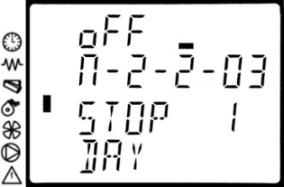
M-2-2-04 START 2 DAY | off/00:00-23:50 | 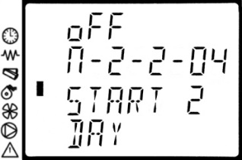
M-2-2-05 STOP 2 DAY | off/00:00-23:50 | 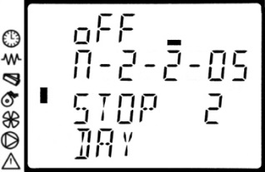

To exit settings, press Key 4. twice.
EXAMPLE OF ADJUSTMENT: The stove switches on at 8 o'clock and switches off at 17 o'clock, and the second switch-on is at 20 o'clock and off at 23 o'clock and 30 minutes. The parameters should be set according to the following table.
M-2-2-01 CHRONO DAY | on
M-2-2-02 START 1 DAY | 06:00
m-2-2-03 STOP 1 DAY | 08:00
m-2-2-04 START 2 DAY | 14:00
m-2-2-05 STOP 2 DAY | 22:30

8.3.3. MENU 02-03 Weekly program

NOTE: During programming, the start-up and shut-down times of the stove must not overlap. At least 30 minutes must elapse between switching off and on!
Weekly program contains 4 independent programs that can be combined during the week. Programs can be combined in such a way that either of them is active or not (OFF or ON). Make sure that the programs are carefully adjusted and that the ignition and shutting off times do not overlap. Programming procedure is as follows: First 4 steps in programming are the same as setting the daily program.
Press the Key 3 (set), after which the text MENU 01 SET CLOCK will be displayed. Then press key 5 twice, after which the screen displays the text MENU 02 SET CHRONO. By pressing the key 3 (set), enter the timer setting menu and therefore the timer setting menu. ENABLE 1 CHRONO will be displayed. Press Key 5 twice and the text M-2-3 PROGRAM WEEK will appear on the screen (Figure 26).
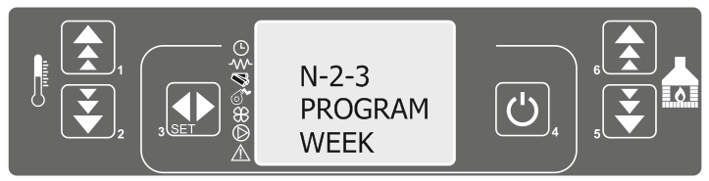
Image 26.

Press Key 3 (set) again, and the screen will display a message:
OFF M-2-3-01 CHRONO WEEKLY (Image 27).
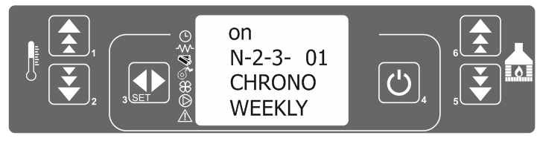
Image 27.
Use Keys 1 and 2 to activate the weekly timer on.
Use keys 5 and 6 to move through the menus, while keys 1 and 2 change parameters.
The menu layouts are shown in the following tables.

PROGRAM 1 |  |  | PROGRAM 2
Menu level | Selection | Possible values | Menu level | Selection | Possible values
02-03-02 | START PROG 1 | Time /off | 02-03-11 | START PROG 2 | Time /off
02-03-03 | STOP PROG 1 | Time / off | 02-03-12 | STOP PROG 2 | Time / off
02-03-04 | MONDAY PROG 1 | on/off | 02-03-13 | MONDAY PROG 2 | on/off
02-03-05 | TUESDAY PROG 1 | on/off | 02-03-14 | TUESDAY PROG 2 | on/off
02-03-06 | WEDNESDAY PROG 1 | on/off | 02-03-15 | WEDNESDAY PROG 2 | on/off
02-03-07 | THURSDAY PROG 1 | on/off | 02-03-16 | THURSDAY PROG 2 | on/off
02-03-08 | FRIDAY PROG 1 | on/off | 02-03-17 | FRIDAY PROG 2 | on/off
02-03-09 | SATURDAY PROG 1 | on/off | 02-03-18 | SATURDAY PROG 2 | on/off
02-03-10 | SUNDAY PROG 1 | on/off | 02-03-19 | SUNDAY PROG 2 | on/off
PROGRAM 3 |  |  | PROGRAM 4
Menu level | Selection | Possible values | Menu level | Selection | Possible values
02-03-20 | START PROG 3 | Time /off | 02-03-29 | START PROG 4 | Time /off
02-03-21 | STOP PROG 3 | Time off | 02-03-30 | STOP PROG 4 | Time off
02-03-22 | MONDAY PROG 3 | on/off | 02-03-31 | MONDAY PROG 4 | on/off
02-03-23 | TUESDAY PROG 3 | on/off | 02-03-32 | TUESDAY PROG 4 | on/off
02-03-24 | WEDNESDAY PROG 3 | on/off | 02-03-33 | WEDNESDAY PROG 4 | on/off
02-03-25 | THURSDAY PROG 3 | on/off | 02-03-34 | THURSDAY PROG 4 | on/off
02-03-26 | FRIDAY PROG 3 | on/off | 02-03-35 | FRIDAY PROG 4 | on/off
02-03-27 | SATURDAY PROG 3 | on/off | 02-03-36 | SATURDAY PROG 4 | on/off
02-03-28 | SUNDAY PROG 3 | on/off | 02-03-37 | SUNDAY PROG 4 | on/off

The times can be set at 10 minute intervals.

Note:
To activate weekend program, day program must be deactivated.

EXAMPLE OF ADJUSTMENT: The stove switches on at 6 o'clock and switches off at 8 o'clock on Mondays, Tuesdays and Fridays. Second switch-on is at 5 hours and 30 minutes and switch-off is at 10 hours on Wednesdays and Thursdays. The third switch on is every day except Saturdays and Sundays from 5 pm and turning off is at 10 pm. On Saturdays and Sundays, the stove is switched on at 8 am and switched off at 11 pm. The parameters should be set as shown in the following tables:

M-2-3-01 CHRONO WEEKLY - ON

PROGRAM 1 |  |  | PROGRAM 2
Menu level | Selection | Possible values | Menu level | Selection | Possible values
02-03-02 | START PROG 1 | 06:00 | 02-03-11 | START PROG 2 | 05:30
02-03-03 | STOP PROG 1 | 08:00 | 02-03-12 | STOP PROG 2 | 10:00
02-03-04 | MONDAY PROG 1 | On | 02-03-13 | MONDAY PROG 2 | off
02-03-05 | TUESDAY PROG 1 | On | 02-03-14 | TUESDAY PROG 2 | off
02-03-06 | WEDNESDAY PROG 1 | off | 02-03-15 | WEDNESDAY PROG 2 | On
02-03-07 | THURSDAY PROG 1 | off | 02-03-16 | THURSDAY PROG 2 | on
02-03-08 | FRIDAY PROG 1 | on | 02-03-17 | FRIDAY PROG 2 | off
02-03-09 | SATURDAY PROG 1 | off | 02-03-18 | SATURDAY PROG 2 | off
02-03-10 | SUNDAY PROG 1 | off | 02-03-19 | SUNDAY PROG 2 | off
PROGRAM 3 |  |  | PROGRAM 4
Menu level | Selection | Possible values | Menu level | Selection | Possible values
02-03-20 | START PROG 3 | 17:00 | 02-03-29 | START PROG 4 | 08:00
02-03-21 | STOP PROG 3 | 22:00 | 02-03-30 | STOP PROG 4 | 23:00
02-03-22 | MONDAY PROG 3 | on | 02-03-31 | MONDAY PROG 4 | off
02-03-23 | TUESDAY PROG 3 | on | 02-03-32 | TUESDAY PROG 4 | off
02-03-24 | WEDNESDAY PROG 3 | on | 02-03-33 | WEDNESDAY PROG 4 | off
02-03-25 | THURSDAY PROG 3 | on | 02-03-34 | THURSDAY PROG 4 | off
02-03-26 | FRIDAY PROG 3 | on | 02-03-35 | FRIDAY PROG 4 | off
02-03-27 | SATURDAY PROG 3 | off | 02-03-36 | SATURDAY PROG 4 | On
02-03-28 | SUNDAY PROG 3 | off | 02-03-37 | SUNDAY PROG 4 | On

8.2.4. MENU 02-04 Program Week-end

NOTE: During programming, the start-up and shut-down times of the stove must not overlap. At least 30 minutes must elapse between switching off and on!
When the weekend programming is activated, on Saturdays and Sundays, the stove start and stop times are the same.
Deactivate daily programming if you want to use weekend programming. Do not use weekend programming if Saturday or Sunday is selected in weekly programs 1-4. Activate the weekend program after deactivating weekly programming.
Press the Key 3 (set), after which the text MENU 01 SET CLOCK will be displayed. Then press key 5 twice after which the text MENU 02 SET CHRONO will appear. By pressing the key 3 (set), enter the timer setting menu and therefore the timer start menu. ENABLE 1 CHRONO is displayed. Then press key 5 three times and the text M-2-4 PROGRAM WEEKEND will appear on the screen (Image 28).

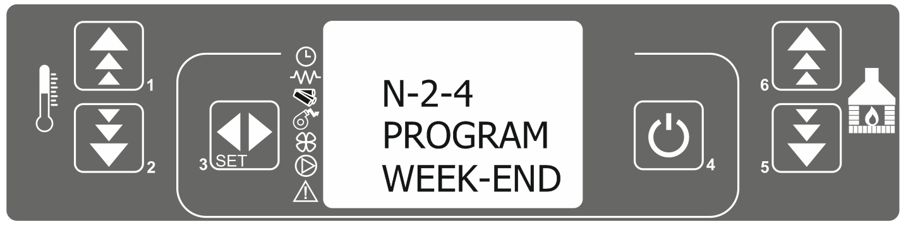
Image 27.
Press key 3 (set) again and the screen will display OFF m-2-3-01 CHRONO WEEKEND. Use keys 1 and 2 switch to ON and to keep the weekend timer on (Figure 28b).
Use keys 5 and 6 to move through the menus, while keys 1 and 2 change parameters.
The programming is done in the same way as in the previous cases (daily and weekly).
The times can be set at 10 minute intervals.
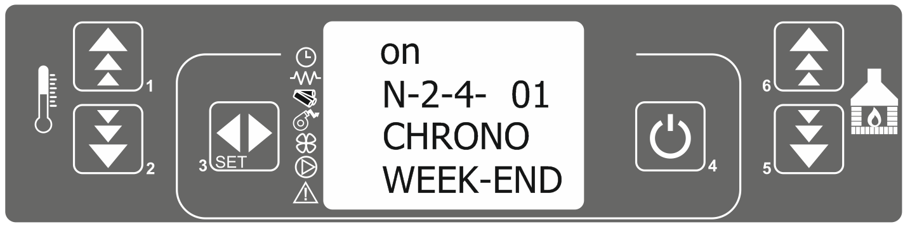
Image 28.

To exit settings, press Key 4. Twice.
EXAMPLE OF ADJUSTMENT: The stove switches on at 8 o'clock and switches off at 17 o'clock, and the second switch-on is at 20 o'clock and off at 23 o'clock and 30 minutes. The parameters should be set according to the following table.

m-2-4-01 CHRONO WEEK-END | on
m-2-4-02 START 1 WEEK-END | 08:00
m-2-4-03 STOP 1 WEEK-END | 17:00
m-2-4-04 START 2 WEEK-END | 20:00
m-2-4-05 STOP 2 WEEK-END | 23:30

8.3. MENU 03 – Language selection

There are four available languages: English, Italian, French and German. The languages are set by pressing Key 3 (set), after which the message MENU 01 SET CLOCK will be displayed. Press Key 5 twice, followed by MENU 03 SELECT LANGUAGE. By pressing Key 3 (set) enter the language setting menu, which will display the language you are currently in, for example MENU 03 ENGLISH.

Changing languages is done by Key 1 and 2. The default language is English.
To exit settings, press Key 4. twice.

8.4. MENI 04 - MENU 04 - Set STAND-BY mode

The STAND-BY mode is used to avoid unnecessary fuel consumption. In stand-by mode, when the room temperature drops 2oC below the set temperature, the stove will automatically enter the ignition phase.
The STAND-BY mode is activated as follows:
By pressing the Key 3 (set) screen will display the text menu 01 SET CLOCK. Press key 5 three times, followed by the text menu 04 MODE STAND-BY (Image 29).
By pressing the 3 key (set), enter the mode activation menu.
You can activate or deactivate the mode with keys 1 or 2.
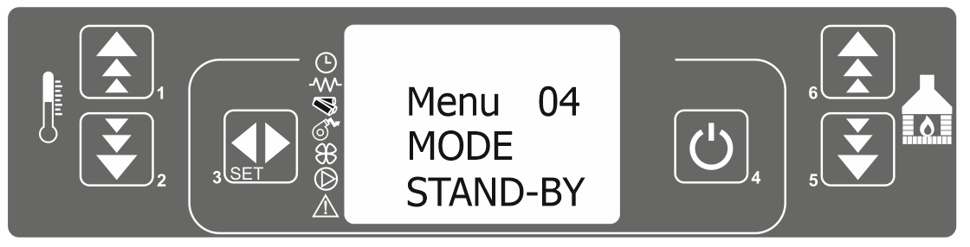
Image 29.

To exit settings, press Key 4. twice.

When the stove enters STAND-BY mode, the screen will show the text as in Image 30.

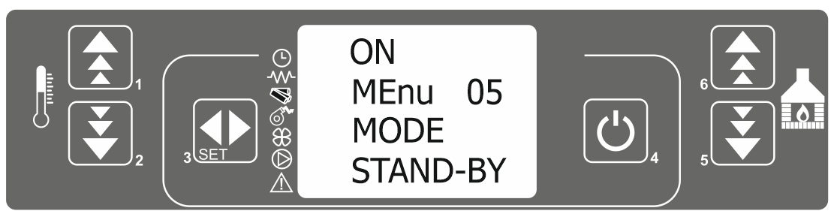
Image 30.

After reaching a temperature that is 2ºC higher than the set room temperature, the stove enters the shutting off phase. In Stand-by mode, when the room temperature drops 2ºC below the set temperature, the furnace automatically enters the ignition phase.
Note: When this mode is on, it is necessary to clean the stove more often.
When the STAND-BY mode is activated, it is recommended to monitor the operation of the kiln to determine possible dust and ash buildup. On this basis, clean regularly, since cleaning depends directly on the quality of the pellets, the room to be heated, the stove and the chimney soiling, and the temperature set.
These details and situations are different from user to user.

8.5. MENU 05 – Set sound-alert

The Alert sound is used to indicate and signal the malfunctioning of the stove. Sound can be turned on or off.
The sound is switched on as follows:
By pressing the Key 3(set), the screen will show text MENU 01 SET CLOCK. Then press the 5 Key four times, followed by the text MENU 05 BUZZER MODE. By pressing the 3 key (set), enter the menu to turn the sound on or off.
Use the 1 or 2 Keys to turn the sound on or off.
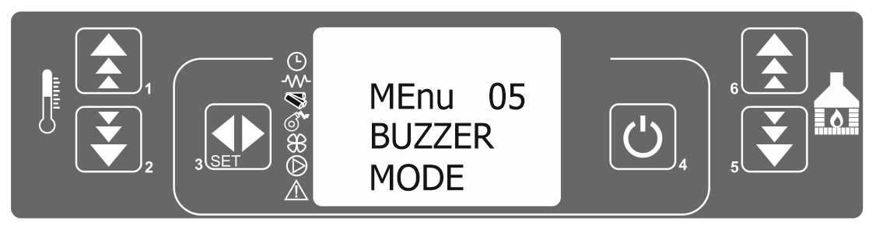
Image 31.

To exit settings, press Key 4. twice.

8.6. MENU 06 – Initial loading

When the all pellet is used, the dozer will be emptied also so that even when the pellet is put into the warehouse, it will take some time for the feeder to be filled before the furnace can start.
When the pellet is emptied, ALARM NO FIRE appears which is described in the ALARMS section. After pouring the pellets into the storage, the following should be done: Press the key 3 (set), after which the text MENU 01 SET CLOCK will be displayed. Then press the 5 key 5 times, followed by the text MENU 06 LOAD INITIAL (Image 32).
By pressing key 3 (set), enter the pellet feeder menu and the text OFF MENU 06 P1 TO LOAD is displayed. Press 1. to fill the pellet dispenser. After 45 seconds, the first pellets will fall into the burning pot.

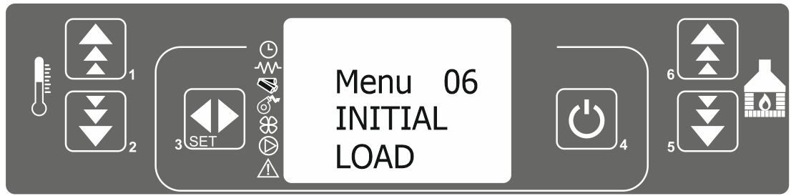
Image 32

To stop loading press Key 4.

Note: Use this function only when the pellet storage is empty.

At the moment when it is evident that the pellet transporter has filled with the pellet and the pellet has started to enter the burning pot, it is necessary to terminate the pellet loading command and start the furnace.
You can only activate this function when the stove is off and the display says OFF.

8.7. MENU 07 – Information related to stove operation status

Information on the operation of the stove is useful because it can be monitored at any time in which mode the stove is operating, the exhaust temperature, the fan speed, the time remaining until the next operation, etc.
To enter the menu that monitors the operation of the stove, do the following: Press Key 3 (set), and the text MENU 01 SET CLOCK will be displayed. Then press the 5 key six times, followed by the text MENU 07 STATE STOVE (Image 33).
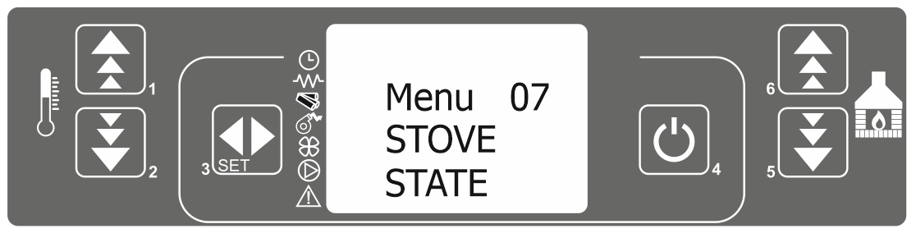
Image 33.
By pressing the Key 3 (set), you enter the menu for displaying the stove status text. The text will alternate and show basic information on the operation of the stove.
Ambient temperature  Pressure in boiler (optional) | 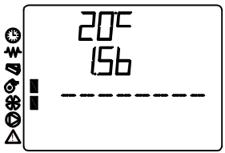
Operation interval (fixed)  Period till operation is finished (count down)  Period from problem detection till sound alarm | 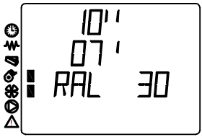
Period of feeder activity (depending on power mode)  Operating mode  Feeder | 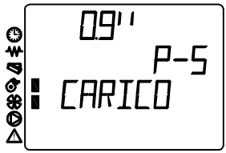
Temperature of exhaust gases  Exhaust fan RPM | 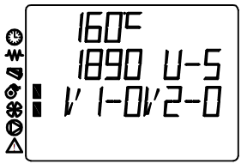
To exit, press Key 4.
Information on the operation of the furnace can also be obtained by pressing certain buttons for 2 seconds. Pressing the button allows you to see the current exhaust temperatures, furnace modes, pellet loading, time remaining until the next operation, etc., as well as going through the MENU 07 menu.

8.8. Technical calibration

IMPORTANT!!!
This menu is reserved for qualified personnel trained in setting the stove, as well as the service technician. Any parameter changes made without the knowledge of authorized person or repairers will entail a loss of warranty.
If you have a problem with overloading the pellet in a cup or poor combustion, call a qualified technician for instructions. Before doing so, make sure that the stove and all ducts in the stove are clean, that the chimney is permeable and made as recommended. Make sure the pellet is of the proper quality.

9. ALARMS

If there is any malfunction of the stove, the control unit signals a problem, including an ice alarm (an LED alarm lights up), and beeps.

 | Alarm origin | Screen appearance
1 | Probe of temperature exhaust gas. | ALARM FLUE PROBE
2 | High temperature of exhaust gases | ALARM HOT TEMP
3 | Ignition malfunction | FAILED IGNITION
4 | Lack of pellet ( during operation ) | ALARM NO FIRE
5 | Power off | BLACK OUT
6 | Low draft | ALARM DEP FAIL
7 | Thermal safety | THERMAL SAFETY
8 | Exhaust gases fan malfunction | EXHAUST FAILURE

Any activation of the alarm causes the stove to shut down immediately!

The alarm starts after a certain period of time (defined by the technical parameters), EXCEPT the POWER OFF P ALARM and can be canceled / deactivated by long pressing of the key 4.
Each time the alarm goes on, for safety reasons, the stove shutdown is also initiated.
While the alarm is active, an LED indicating the alarm is blinking. Where an acoustic signal is also activated, it will beep even.
In case the alarm is turned off , the furnace will be switched off by itself and the text about the type of alarm will appear on the screen.
When switching off, press the 4 key (minimum 4 seconds) until the display shows CLEANING FINAL, indicating that the stove has entered the shutdown process or cancellation of the alarm.

1. ALARM - EXHAUST GAS TEMPERATURE SENSOR

Reason: This alarm will be triggered if the exhaust probe breaks down. An alarm will sound and the corresponding LED lights up. The following message "ALARM FLUE PROBE" will be displayed and the stove will go off.

What to do? Check that the exhaust gas temperature probe is connected securely and not accidentally broken. If the probe is interrupted, call a service technician to change the defective probe. The exhaust gas temperature probe cannot be continued or tied up (call a workshop to replace the probe).
In some cases, the tip of the probe (located inside the exhaust fan turbine housing) is soiled and registers the wrong exhaust temperature values. The solution is to clean the tip of the probe, taking care not to damage the probe.

2. ALARM OF EXHAUST GASES HIGH TEMPERATURE

Reason: This alarm will sound if the exhaust probe shows a higher temperature than the constant and steady temperature. "ALARM HOT TEMP" will be displayed and the stove will go off.
What to do? If this message often occurs, call a service technician. The stove can be conditionally used in lower operating modes than those in which this message appeared. Solution is to reduce the power, to check the door and ashtray tightness and to perform detailed furnace and chimney maintenance.

3. ALARM OF FAILED IGNITION

Reason: If the stove does not start, an alarm will sound. This happens if, after a certain period of time, the exhaust gas temperature does not reach the value set by the manufacturer (whether or not the pellet in the cup ignites). "FAILED IGNITION" will appear on the screen and the stove will go into alarm mode. An error may occur due to:
- Pellet jamming in the pellet conveyor
- Defective lighter
- Insufficient quantity of pellets required for ignition,
- Damage or soiling of the probe that measures the exhaust gas temperature
- Low exhaust temperature.
What to do? Checking whether the burning pot is filled with pellet is only possible by observing the tube through which the pellet enters the burning pot for at least 60 seconds.
If there is no pellet loading, there are two possible causes:
- Pellet storage is empty,
- Pellet is stuck in the pellet conveyor.
If the pellet is stuck, try starting the stove several times. If the stove cannot start, unplug it and clean the pellet conveyor.
IMPORTANT! The jammed pellet is cleaned only when the stove is disconnected from the power supply! If the pellet conveyor is stuck, do not place your fingers in the pellet storage area while the stove is running!
Malfunction of lighter can be observed when there are no sparks or hot pellets when starting the stove. Over time, the power of the lighter decreases and its deformation is possible. A deformed lighter touches the tube in which it is located and transfers some of its heat to it. Because of this, the lighter does not transfer enough temperature to the pellet and does not ignite. In case of urgent need, add pellet in to burning pot and start fire manually with fire starter (cube or a gel), for ignition, but it is necessary to contact an authorized service as soon as possible and install a new lighter.

- ALARM OFF PELLET DEFICIENCY
The reason: Due to the lack of pellets and less combustion, the exhaust gas temperature drops below the values determined by the parameters. "ALARM NO FIRE" will appear on the screen and the stove will enter alarm mode.
What to do? Cancel the alarm and wait for the stove to cool. Then, proceed as described in Section 8.6 Menu 06 - START PELLET INSTALLATION and start the stove.
NOTE: This alarm can also occur due to a pellet jam in the pellet conveyor.

- ALARM POWER OUTAGE
Reason: There may be a power outage while the stove is operating. If the power failure is shorter than the time specified by the technical parameter, when the oven is switched on again, it will continue to operate in operating mode. Otherwise, the alarm will sound. The message "BLACK OUT" will appear on the screen and the oven will switch off on its own.
- ALARM OF INSUFICIENT UNDERPRESSURE IN THE FIREBOX
Reason: The alarm is triggered when the underpressure in the firebox is below the level required for ignition and combustion of the pellets. The presser will react by suspending the operation of the pellet conveyor.
The display shows "ALARM DEP FAIL" and the oven switches off.
A fault in the safety gap can occur if:
-the oven dirty,
-the oven doesn't breathe well
-if the chimney or smoke ducts in the furnace are clogged,
- if the fan speed is insufficient,
- due to strong wind.
What to do? Clean the stove and flue pipes. Check that the door of the firebox and the ashtray are well closed. Check that the braids located on the door and the ashtray are in good condition. If the braids are well placed, check the chimney pressure.
The chimney is checked by bringing the flames to the smoke outlet on the wall (rosette). If the flame turns toward the smoke outlet then a underpressure is appropriate. If the flame returns to the room or if it is stationary then the chimney overpressure is bad. In that case, call the chimney sweep. Cleaning the stove is described in the section “CLEANING AND MAINTENANCE”.

7. THERMAL SAFETY ALARM (THERMOSTAT)

The reason: The function of the safety thermostat is to prevent the pellets from burning inside the pellet storage due to the increased temperature in the pellet conveyor tube. An alarm will sound if the safety thermostat shows a temperature higher than that required to start the stove. The thermostat responds by switching off the pellet conveyor and the control unit activates alarm mode (LED alarm lights). The screen shows the text "THERMAL SAFETY". Stove will shut down.

What to do? Cancel the alarm: Unscrew the safety thermostat cover (1) and check that the needle (2) is pulled in or out. If the needle is pulled out, press the needle and put the stove back into operation. If the needle is retracted or unable to retract and the stove still reports the same error, call a service technician. | 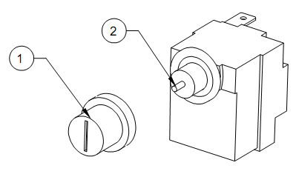

- ALARM MALFUNCTION OF EXHAUST FAN
Reason: An alarm occurs if the exhaust fan malfunctions. The display shows "EXHAUST FAILURE".
An error may occur due to:
- fan blocking,
- malfunctions of the contact supplying the fan with electricity,
- disconnects cables that measure fan speed.
If this error occurs, be sure to contact service technician.
The alarm can also be triggered by an increase inside the exhaust fan temperature.
What to do? In this case it is necessary to clean the stove (monthly cleaning), as well as the blades of the fan.

9. ALARM MALFUNCTION OF AMBIENTE TEMPERATURE PROBE
If the ambient temperature probe is malfunctioning, the scree will indicate 00.0 º C. If the real room temperature is 0 º C, the same will be displayed. Hold the tip of the probe to be heated by holding it between your fingers. Check the screen if temperature is increasing.
If this does not happen then the probe is defective. If the probe malfunctions, call a service technician.

10. CLEANING AND MAINTENANCE

During the daily and weekly cleaning turn off the stove at the main switch, set the switch in position “0”. When the stove is being completely cleaned you must shut it off from the power source.
Stove can be cleaned at least 30 minutes after the cessation of work, in order to avoid burns in contact with hot parts of the stove. When cleaning with a damp cloth or water, be careful that water does not reach the electrical parts of the stove. If it happens, by chance, do not to turn on the stove and call the authorized service.
When cleaning the stove, avoid strong detergents and abrasives, and all products containing solvents, alcohols, acids, or any solvent.
Glass is being cleaned with a dry cloth, if there are a traces of soot, the glass can be cleaned with a damp cloth, but then wiped again with a dry cloth..
Painted and plastic parts clean with a slightly damp cloth, and use only a mild detergent diluted with water.

Daily cleaning
Includes a glass cleaning and cleaning of glass cups where the burning process takes place. The ash remained in the cup put away from flammable elements, in order to prevent possible remains of some incandescent pellets. Make sure that all the holes in the cup are well cleaned. You can also clean and ashes from the firebox. To clean the ashes from the firebox, you can use the vacuum cleaner.

Note: Door handle ,in case of TARRA stove is separate part and it should be kept in the hook on the rear side of the stove. Image 33 presents opening of doors of TARRA stove for daily (or weekly/monthly) maintenance.

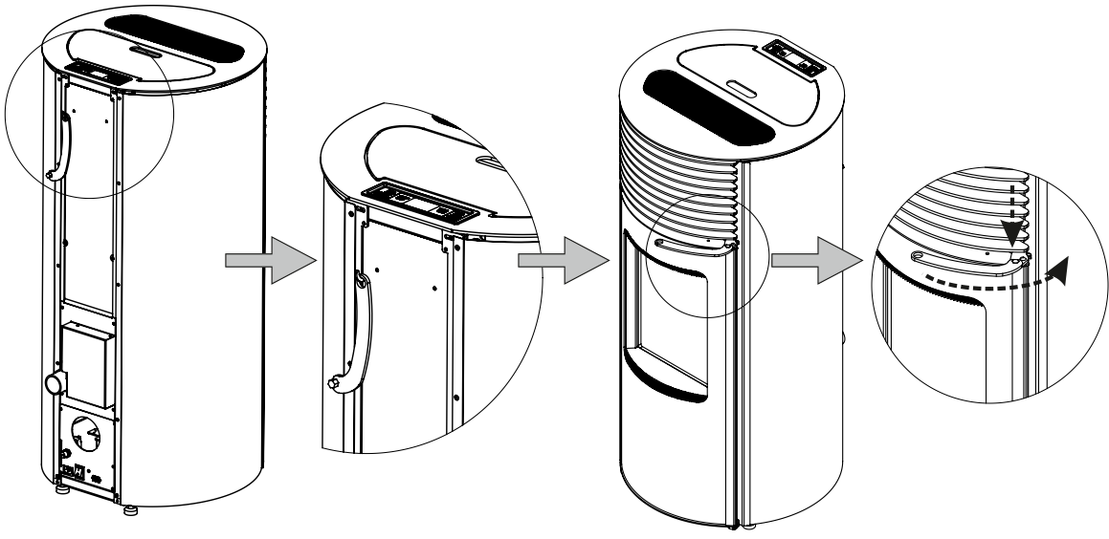
Image 33. Use of door handle on TARRA stove

Image 34.presents parts for daily and weekly cleaning

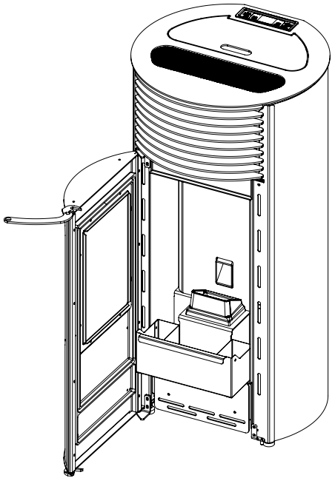 | 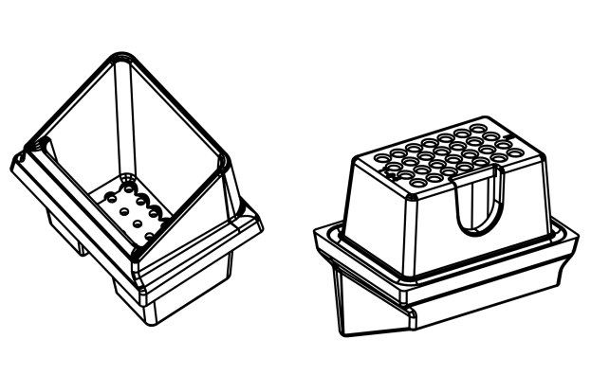
Image 34. Parts for Daily and weekly cleaning

Weekly cleaning
In addition to daily cleaning, it is necessary to empty the ash pan at least once a week if you’re using more pellets. Periodically, check the rope on the ashtray because it’s condition is very important for stove proper operation. In case that ashtray is not sealed perfectly and air is passing through in to the stove, change of rope is recommended.

Monthly cleaning
Stove has to be cleaned completely once in a month and at the end of the heating season. In addition to instructions for weekly and daily cleaning it’s necessary to open the stove on provided spots and clean it accurately.
During the monthly cleaning, act by a following order in removing parts (Image 34). When getting all parts together do it in a reverse order.
Use monthly cleaning to check the condition of exhaust tubes and chimney. Clean if needed.
Take a careful check of ropes and gaskets on cleaning cover, doors and ashtray.

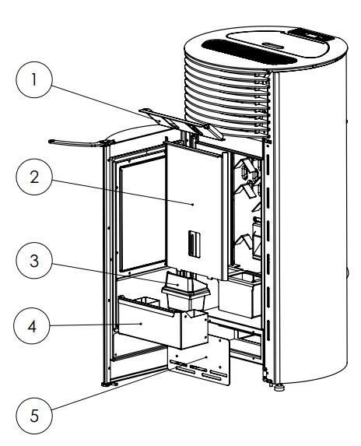

Image 35. Schedule of disassembling for monthly cleaning
WARRANTY

Stove will work well only if you follow the given instructions.
TIM SISTEM is obligated to provide spare parts and eliminate interference with the stove that are covered by this warranty within the time limit not exceeding 45 days from the date of defect report.
If the defect is not corrected within 45 days, you have the right to a substitution for a new product.
The warranty is valid from the date of purchase, as evidenced by duly completed guarantee certificate, and the shop’s receipt.
The warranty for this product is 25 months.

For any defect you need to call a qualified technician. All defects must be removed by an authorized service technician. In case that an unauthorized person repairs a stove, you will automatically lose a warranty and any further repairs by an authorized service will be charged.

TIM SISTEM is obliged to provide spare parts in due time after the stove is no longer produced.
This warranty does not cover damage caused by:

- inadequate use of stoves;
- violating the instructions given in this manual;
- mechanical damage incurred due to inadequate storage and transport;
- due to mechanical damage caused by kicking, tumbling;
- due to inadequate exposure to rain, snow etc.;
- due to chemical damage caused by exposure to inflammatory agents such as
oil and oil products, alcohol, solvents, paints;
- due to natural disasters such as lightning, floods, fire;
- due to chemical damage caused by exposure to combustible agents such as petroleum and petroleum products, acids, corrosive and corrosive agents, alcohol, paint and thinner;
- due to natural disasters such as lightning, floods, fire;

The parts subjected to wear, such as braiding (glass), gaskets, rubber parts (rubber feet, spacers), are not covered by this warranty.
Damages of fire resistant and heat resistant door glass which are caused by extreme temperature changes of physical force are not covered with this warranty.

All malfunctions report in written or orally by telephone, on the address listed at the end of this Manual.

__________________________________________________
__________________________________________________
__________________________________________________
__________________________________________________
__________________________________________________
__________________________________________________
__________________________________________________
__________________________________________________
__________________________________________________
__________________________________________________
__________________________________________________
__________________________________________________
__________________________________________________
__________________________________________________
__________________________________________________
__________________________________________________
__________________________________________________
__________________________________________________
__________________________________________________
__________________________________________________
__________________________________________________
__________________________________________________
__________________________________________________
__________________________________________________
__________________________________________________
__________________________________________________
__________________________________________________
__________________________________________________
__________________________________________________
__________________________________________________
__________________________________________________
__________________________________________________

OBLIGATORY!
READ MANUAL BEFORE STARTING THE STOVE.

TIM SISTEM d.o.o.
ul.Prva industrijska br. 9
22 330 Nova Pazova, Srbija
tel/fax: +381 22 32 80 76
e-mail:servis@timsistem.rs
www.timsistem.rs

